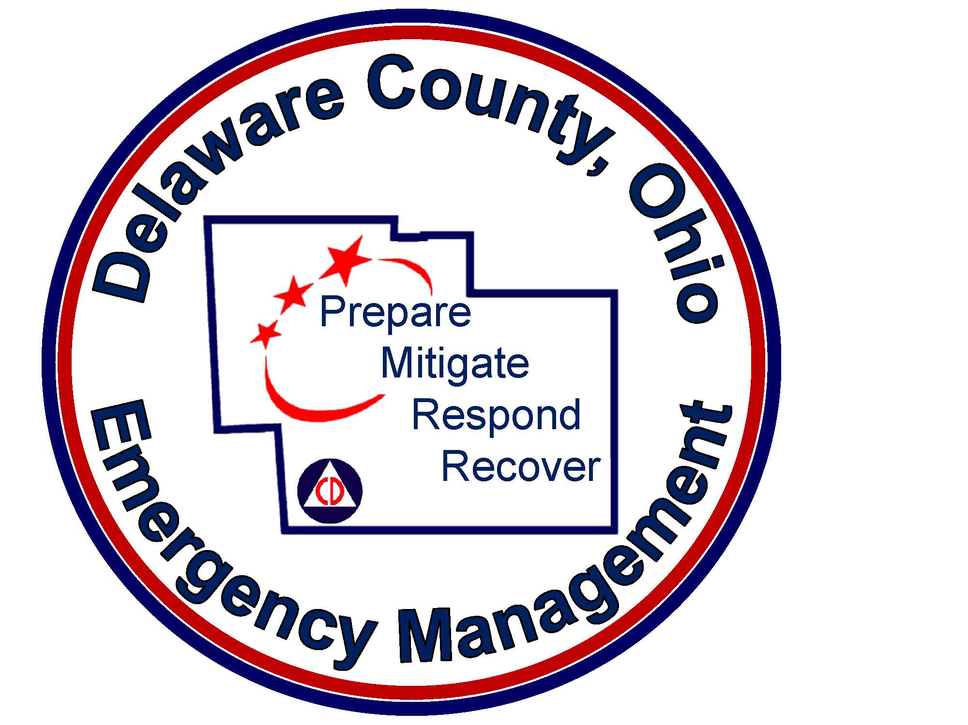
DELAWARE COUNTY LEPC
8 OCT 2020
2:00PM
Delaware County Emergency Management Agency
Virtual Meeting

Agenda

1. Roll Call/Attendance

2. Pledge of Allegiance

3. Approval of Minutes

Handouts if any

5. Old Business
A. SERC Grant

6. Director of EMA Report – Sean Miller

7. Committee Reports

- Hazmat-DART Duty Officer – DART Drills
- Incidents/Training – Specialist Scott Stewart
- Industrial-Mike Tankersley – Kroger Distribution
- Public Information- Jane - Sandy
- Security-Captain Scott Vance

8. New Business
A. Compliance Report and Enforcement Letters
B. EMA/LEPC Resolution
C. Public Comment Review
D. Plan Update
E. LEPC 2020 Exercise
F. 2020 Meeting Dates Reminder
- 1/14/2021 @ 2:00pm
- 4/08/2021 @ 2:00pm
- 7/08/2021 @ 2:00pm
- 10/14/2021 @ 2:00pm

9. Public Comments
PLEASE NOTE: This meeting will be held virtually on Zoom. Please see the login information below. Live public comments will be accepted during the comment period as listed in the agenda, and commenters are asked to maintain the same rules of decorum as they would at a traditional public meeting.

Zoom Meeting
https://zoom.us/j/5878506578?pwd=VjM3UjdlVktXZ2pkTE9GNTc5ZmcvZz09
Meeting ID: 587 850 6578
Passcode: 652700
One tap mobile
+13126266799,,5878506578#,,,,,,0#,,652700# US (Chicago)
+16465588656,,5878506578#,,,,,,0#,,652700# US (New York)
Dial by your location
+1 312 626 6799 US (Chicago)
+1 646 558 8656 US (New York)
+1 301 715 8592 US (Germantown)
+1 346 248 7799 US (Houston)
+1 669 900 9128 US (San Jose)
+1 253 215 8782 US (Tacoma)
Meeting ID: 587 850 6578
Passcode: 652700

10. Motion to Adjourn

NEXT MEETING 2:00 PM
1/14/2021

